Experiment 3

Aim:  Customize webpage using audio/video and geo location.

Theory:

1)Video tag:

The HTML <video> element is used to show a video on a web page.

Working :

The controls attribute adds video controls, like play, pause, and volume.

It is a good idea to always include width and height attributes. If height and width are not set, the page might flicker while the video loads.

The <source> element allows you to specify alternative video files which the browser may choose from. The browser will use the first recognized format.

The text between the <video> and </video> tags will only be displayed in browsers that do not support the <video> element.

Add muted after autoplay to let your video start playing automatically.

# 2) Geolocation:

The HTML Geolocation API is used to locate a user's position.

Since this can compromise privacy, the position is not available unless the user approves it.

The getCurrentPosition() method is used to return the user's position.

The Geolocation object also has other interesting methods:

* watchPosition() - Returns the current position of the user and continues to return updated position as the user moves (like the GPS in a car).
* clearWatch() - Stops the watchPosition() method.

Code:

HTML for video and Geolocation:

<!DOCTYPE html>

<html lang="en">

<head>

    <meta charset="UTF-8">

    <meta name="viewport" content="width=device-width, initial-scale=1.0">

    <title>Document</title>

    <link rel="stylesheet" href="style.css">

</head>

<body>

    <header>

        <video autoplay loop muted plays-inline class="bg-video">

            <source src="images and videos/clip.mp4" type="video/mp4">

        </video>

     <div class="main">

         <div class="logo">

            <img src="images and videos/Frame 1.png" alt="" id="logo">

         </div>

     <ul>

         <li class="active"><a href="#">Home</a></li>

         <li><a href="#">About us</a></li>

         <li><a href="#">Contact</a></li>

         <li><button class="login">login</button></li>

         <li><button class="SignUp">Sign Up</button></li>

     </ul>

     </div>

     <div class="hero">

        <h1>WE ARE...</h1>

        <h2>an event , design , planning and creative consulting company specializing in customised experience for our clients and their guests</h2>

        <div>

            <select name="Location" id="" class="optlocation">

                <option value="All">All LOCATIONS</option>

                <option value="London">London</option>

                <option value="Mumbai">Mumbai</option>

                <option value="Pune">Pune</option>

                <option value="Nagpur">Nagpur</option>

            </select>

            <select name="CAtegory" id="" class="optcategory">

                <option value="All Categories">All CATEGORIES</option>

                <option value="London">London</option>

                <option value="Mumbai">Mumbai</option>

                <option value="Pune">Pune</option>

                <option value="Nagpur">Nagpur</option>

            </select>

        </div>

        <div class="Explorebutton">

            <button class="Explore">

                Explore

            </button>

<div class="aboutUs" id="aboutUs">

    <h1>About Us</h1>

    <p>Lorem ipsum dolor sit amet consectetur, adipisicing elit. Omnis ea, earum, quod voluptatum, exercitationem blanditiis provident fugit illo pariatur quos fugiat dicta cumque quas sint optio porro adipisci expedita? Sunt.</p>

    <div class="bt">

        <button id="Exploremore">Explore More</button>

    </div>

</div>

<div class="Services" id="Services">

    <div class="container">

        <div class="box">

            <img src="" alt="">

        </div>

        <div class="box">

            <img src="" alt="">

        </div>

        <div class="box">

            <img src="" alt="">

        </div>

        <div class="box">

            <img src="" alt="">

        </div>

        <div class="box">

            <img src="" alt="">

        </div>

        <div class="box">

            <img src="" alt="">

        </div>

        <div class="box">

            <img src="" alt="">

        </div>

        <div class="box">

            <img src="" alt="">

        </div>

        <div class="box">

            <img src="" alt="">

        </div>

    </div>

    <div class="Contactus" id="Contactus">

    <h1>Contact Us</h1>

    <div class="map-wrapper">

        <iframe src="https://www.google.com/maps/embed?pb=!1m18!1m12!1m3!1d3772.669319454159!2d73.12509517471877!3d18.99020605466122!2m3!1f0!2f0!3f0!3m2!1i1024!2i768!4f13.1!3m3!1m2!1s0x3be7e866de88667f%3A0xc1c5d5badc610f5f!2sPillai%20College%20of%20Engineering%2C%20New%20Panvel%20(Autonomous)!5e0!3m2!1sen!2sin!4v1707770577804!5m2!1sen!2sin"

        width="500" height="350" style="border:0;" allowfullscreen="" loading="lazy" referrerpolicy="no-referrer-when-downgrade"></iframe>

      </div>

    </div>

</div>

<section class="footer">

    <div class="box-container">

        <div class="boxf">

            <h3>quick links</h3>

            <a href="">Home</a>

            <a href="">About us</a>

            <a href="">Contact us</a>

            <a href="">LOGIN</a>

            <a href="">SIGN UP</a>

            <a href="">Explore</a>

        </div>

        <div class="boxf">

        <h3>Conatct Details</h3>

        <a href="">+12345678</a>

        <a href="">+12345678 </a>

        <a href="">abc@gmail.com</a>

        <a href="">abc@gmail.com</a>

        <a href="">abc@gmail.com</a>

        <a href="">Navi Mumbai, New Panvel</a>

        </div>

    </div>

</section>

</body>

</html>

CSS CODE for video AND geolocation implementation:

*{

    margin: 0;

    padding: 0;

    font-family: 'Times New Roman', Times, serif;

}

header{

    height: 100vh;

    background-size: cover;

    background-position: center;

    background-attachment: fixed;

}

.bg-video{

    position: absolute;

    right: 0;

    bottom: 0;

    z-index: -1;

}

@media(min-aspect-ratio:16/9){

    .bg-video{

        width: 100%;

        height: auto;

    }

}

@media(max-aspect-ratio:16/9){

    .bg-video{

        width: auto;

        height: 100%;

    }

}

ul{

    float: right;

    list-style-type: none;

    margin-top: 40px;

    gap: 10vh;

    background-color: gradient(rgb(0,0,0,0.5));

}

ul li{

    display: inline-block;

    gap: 8px;

}

ul li a{

    text-decoration: none;

    color: #dad8d8;

    padding: 5px 20px;

    border: 1px solid transparent;

    border-radius: 1vh;

}

ul li.active a{

    background-color:#F3347D;

    border: #F3347D;

    color: #fff;

}

ul li a:hover{

    background-color:#F3347D;

    border: #F3347D;

    color: #fff;

    transition: .4s ease all;

}

ul li .login{

    text-decoration: none;

    background-color: transparent;

    color: #dad8d8;

    padding: 5px 20px;

    border: 1px solid #F3347D;

    border-radius: 1vh;

}

ul li .login:hover{

    background-color:#F3347D;

    border: #F3347D;

    color: #fff;

    transition: .4s ease all;

}

ul li .SignUp{

    text-decoration: none;

    background-color: transparent;

    color: #dad8d8;

    padding: 5px 20px;

    border: 1px solid #F3347D;

    border-radius: 1vh;

}

ul li .SignUp:hover{

    background-color:#F3347D;

    border: #F3347D;

    color: #fff;

    transition: .4s ease all;

}

.logo img{

    float: left;

    width: 200px;

    height: auto;

    margin: 10px;

}

.main{

    max-width: 1200px;

    margin: auto;

}

.hero{

    position: absolute;

    top:50%;

    left: 50%;

    transform: translate(-50%, -50%);

    z-index: 99;

    background-color: gradient(rgb(0,0,0,0.5));

}

.hero h1{

    color: #fff;

    font-size: 70px;

}

.hero h2{

    color: #fff;

    font-size: 30px;

}

.optlocation{

    display: inline-block;

    background-color: transparent;

    color: #fff;

    padding: 10px 30px;

    border: 1px solid #fcfcfc;

    border-radius: 1vh;

    font-size: 15px;

    margin: 10px 0px 10px 50px;

}

.optcategory{

    display: inline-block;

    background-color: transparent;

    color: #fff;

    padding: 10px 30px;

    border: 1px solid #fcfcfc;

    border-radius: 1vh;

    font-size: 15px;

    margin: 10px 50px 10px 50px;

}

.Explorebutton{

    position: absolute;

    top:110%;

    left: 40%;

    transform: translate(-50%, -50%);

    z-index: 99;

}

.Explore{

    text-decoration: none;

    background-color: #fcfcfc;

    color: #F3347D;

    padding: 5px 20px;

    border-radius: 1vh;

    border-color: transparent;

    box-shadow: none;

    font-size: 20px;

}

.Explore:hover{

    background-color:#F3347D;

    border: #F3347D;

    color: #fff;

    transition: .2s ease all;

    box-shadow: 2px,rgba(0,0,0,0.5);

    font-size: 20px;

}

Output:

Video used in Background.



Geolocation:

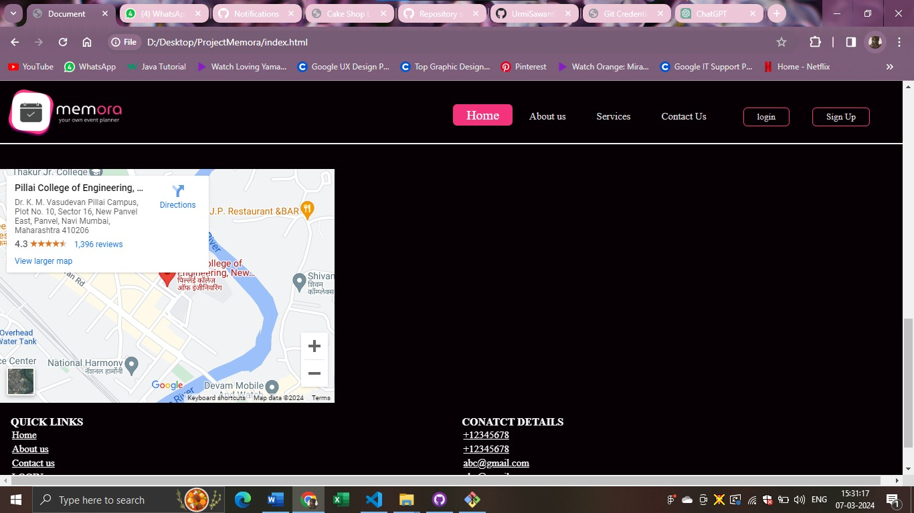

Conclusion: Thus, we have successfully created a web page using Html and CSS with the help of Geolocation and video Tags. In conclusion, the integration of video and geolocation features into HTML provides a rich and dynamic experience for web applications. Incorporating video elements allows developers to seamlessly integrate multimedia content into their websites, enhancing engagement and storytelling capabilities. With HTML5's native video support, compatibility across different devices and browsers is greatly improved, enabling a broader audience to access and interact with video content.